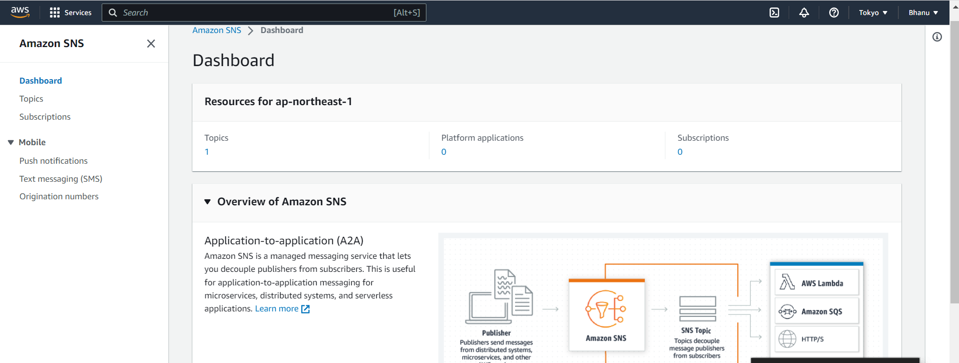

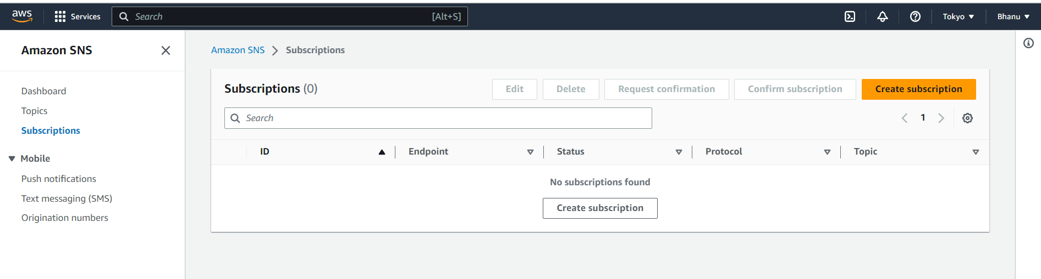

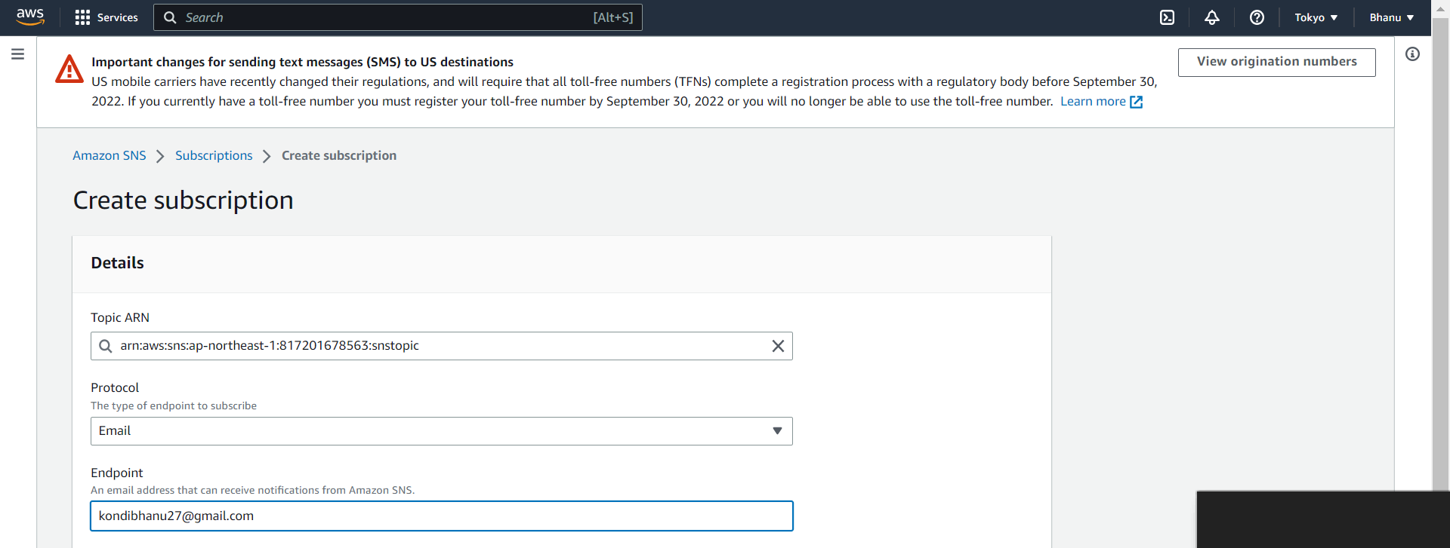

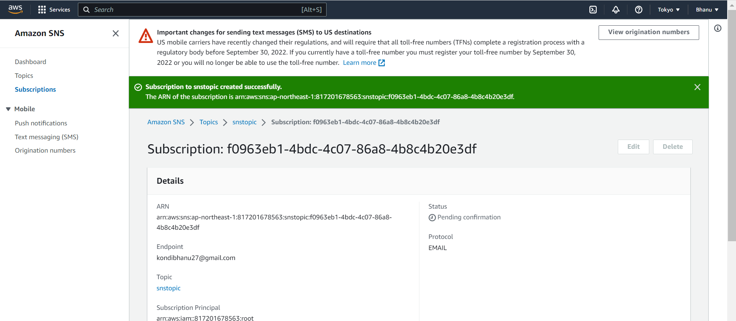

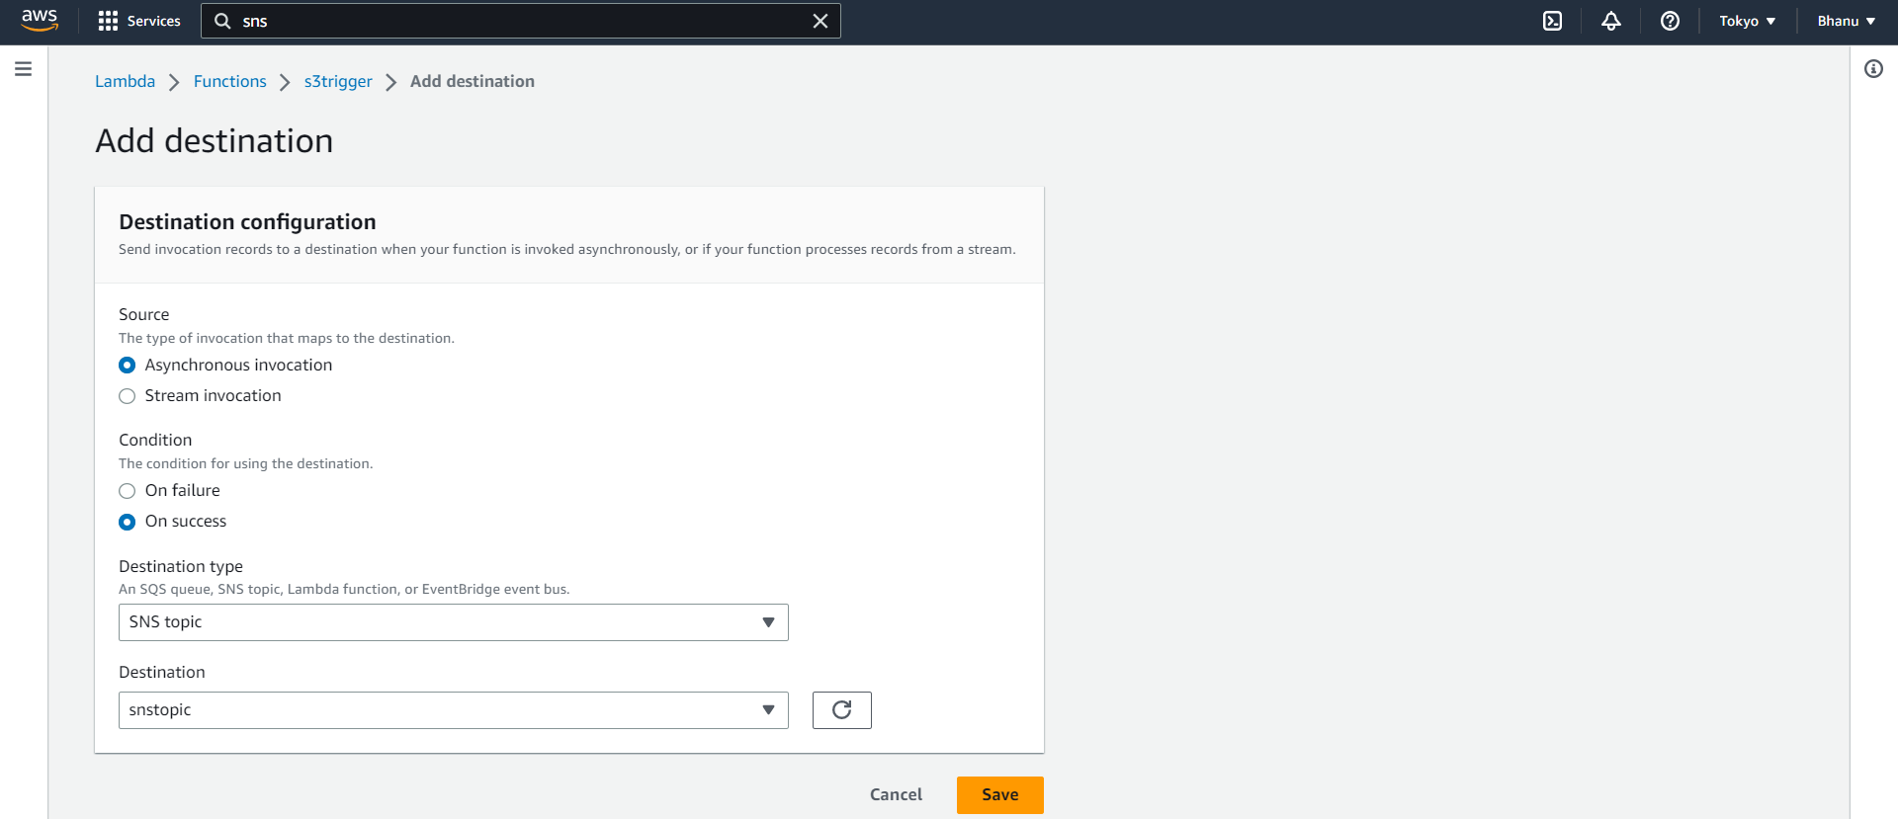

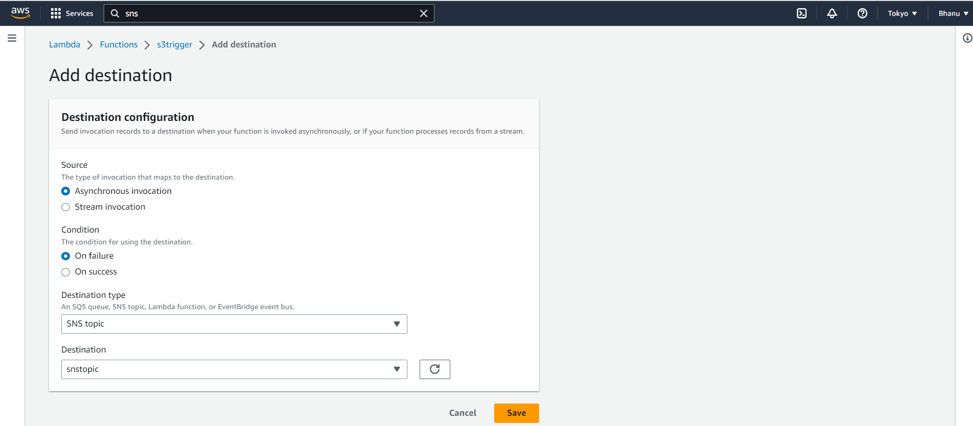

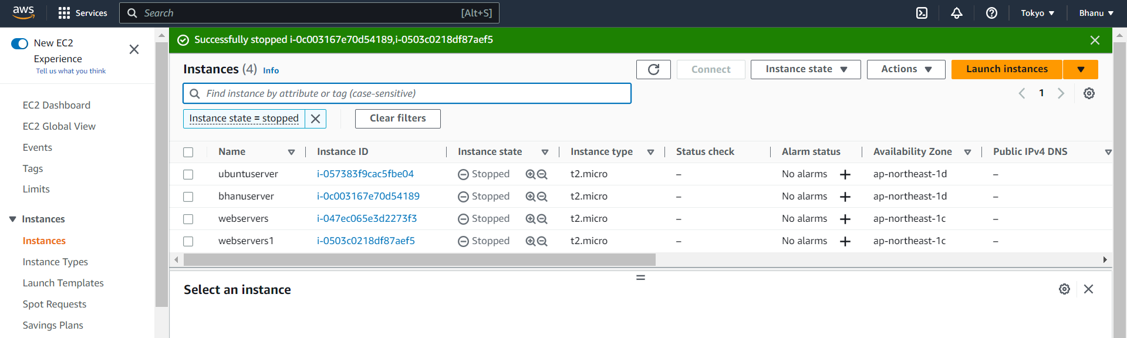

Go to lambda and click on test.

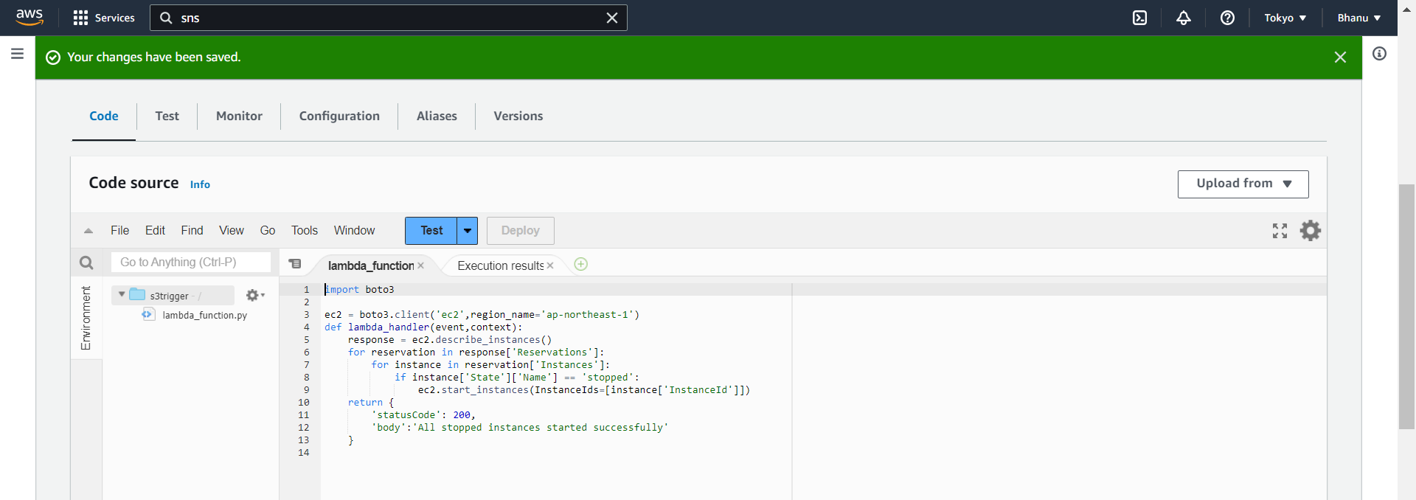

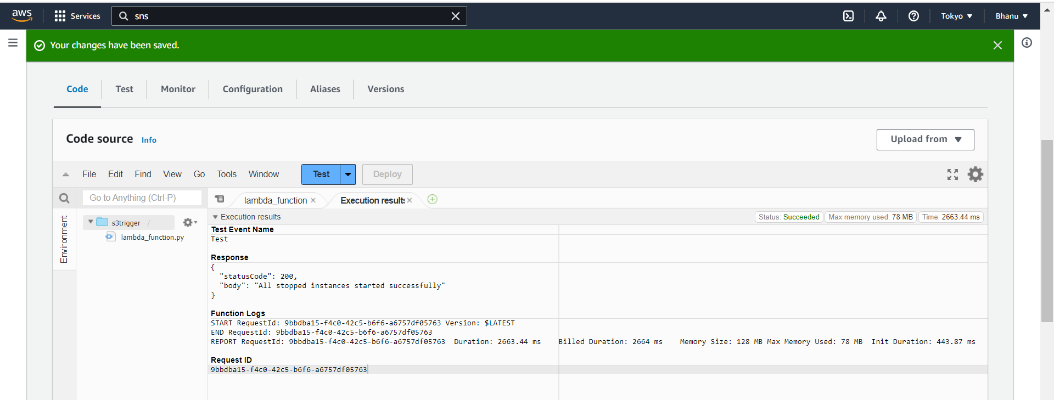

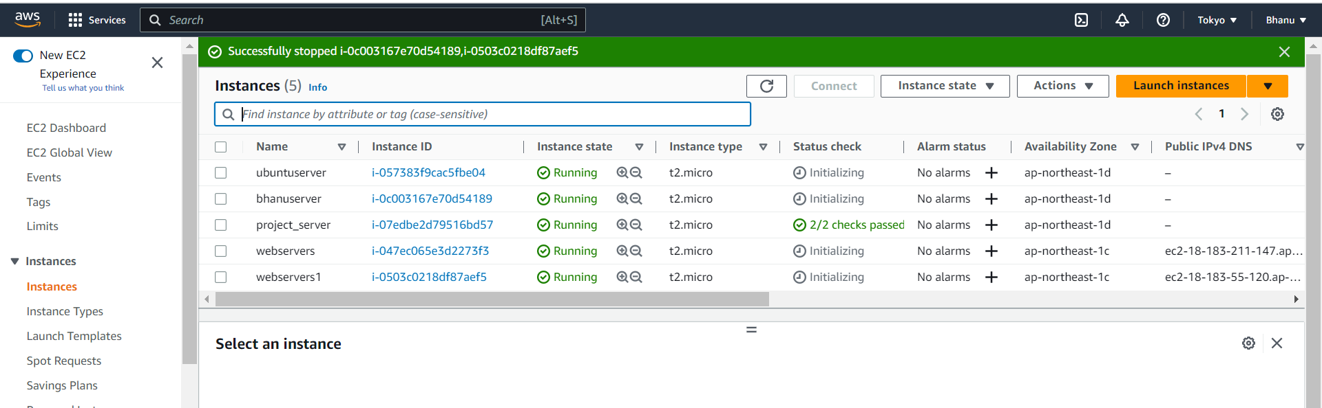

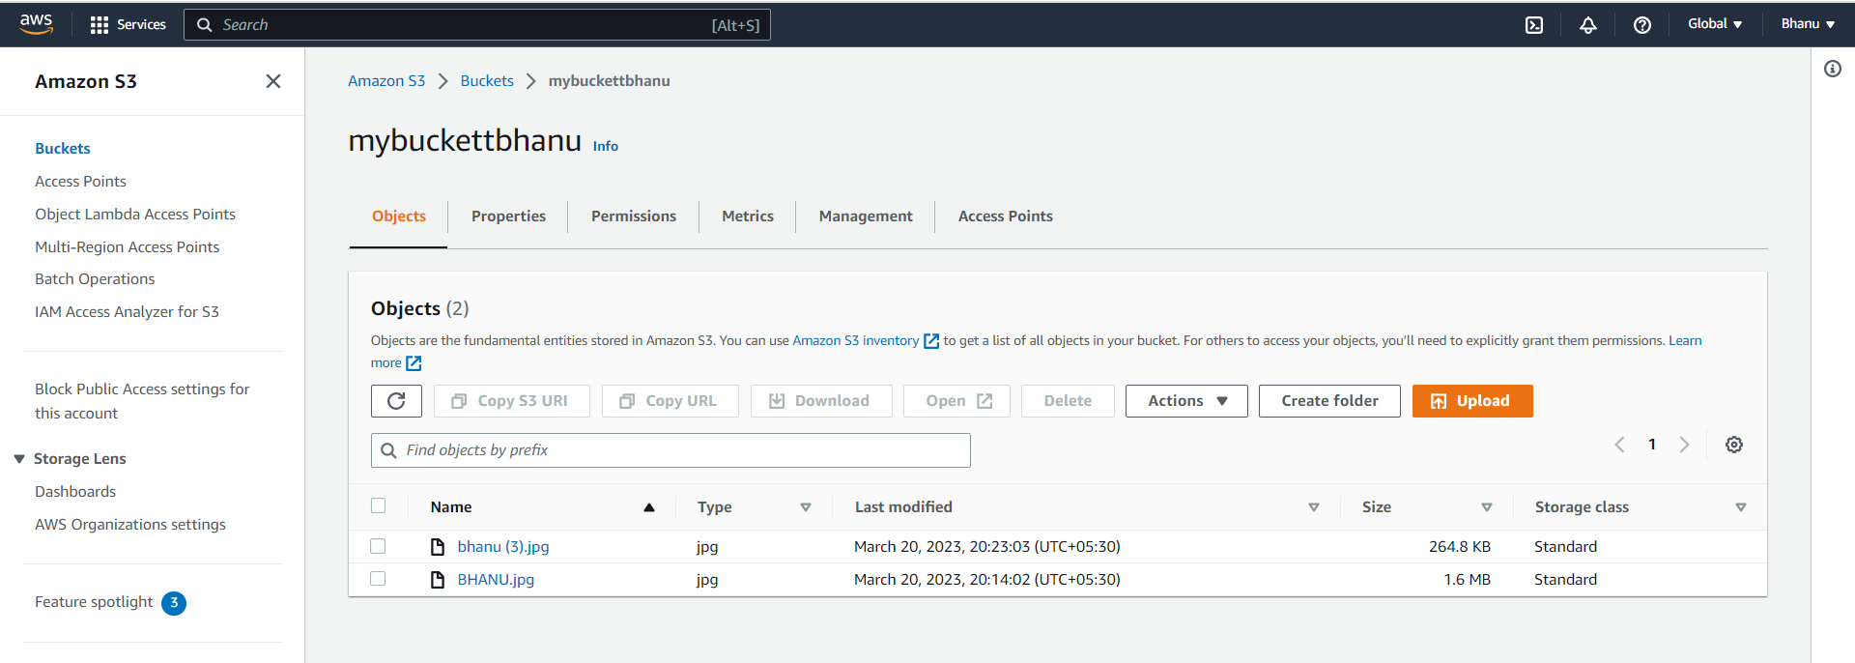

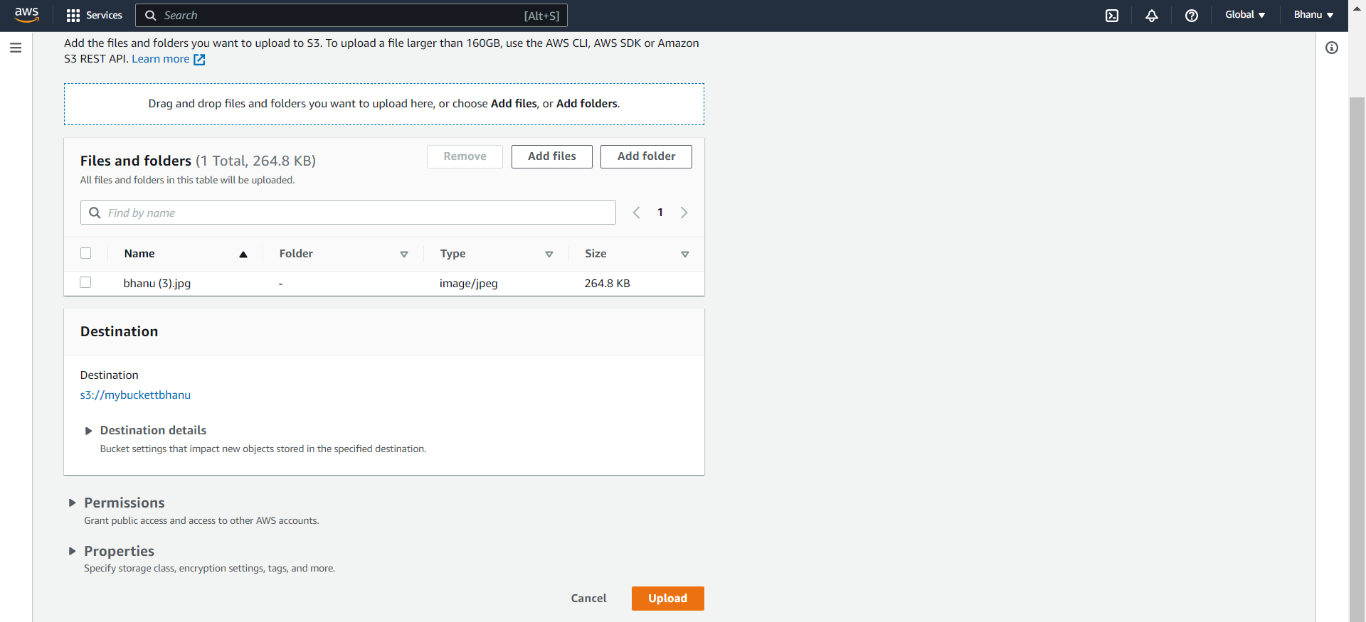

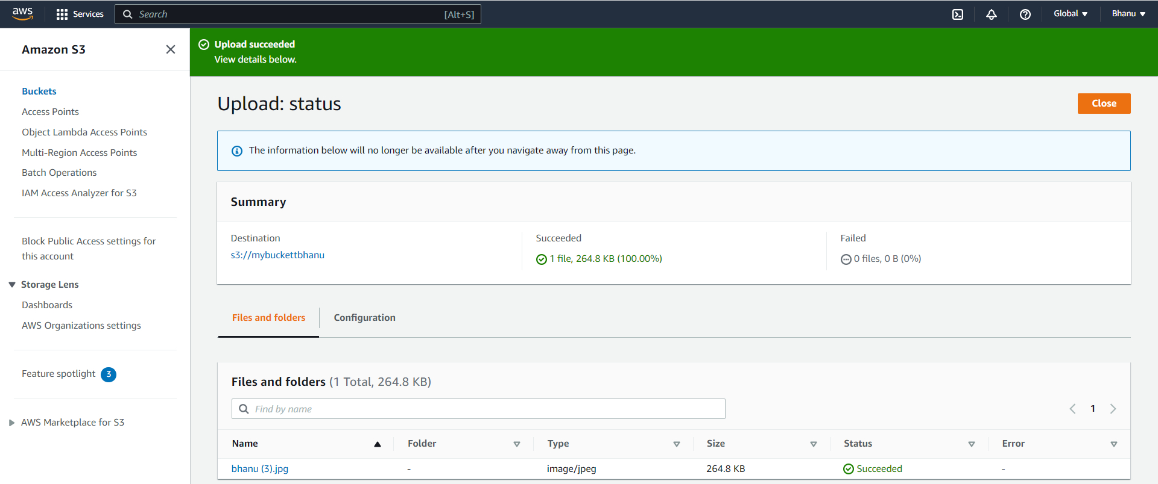

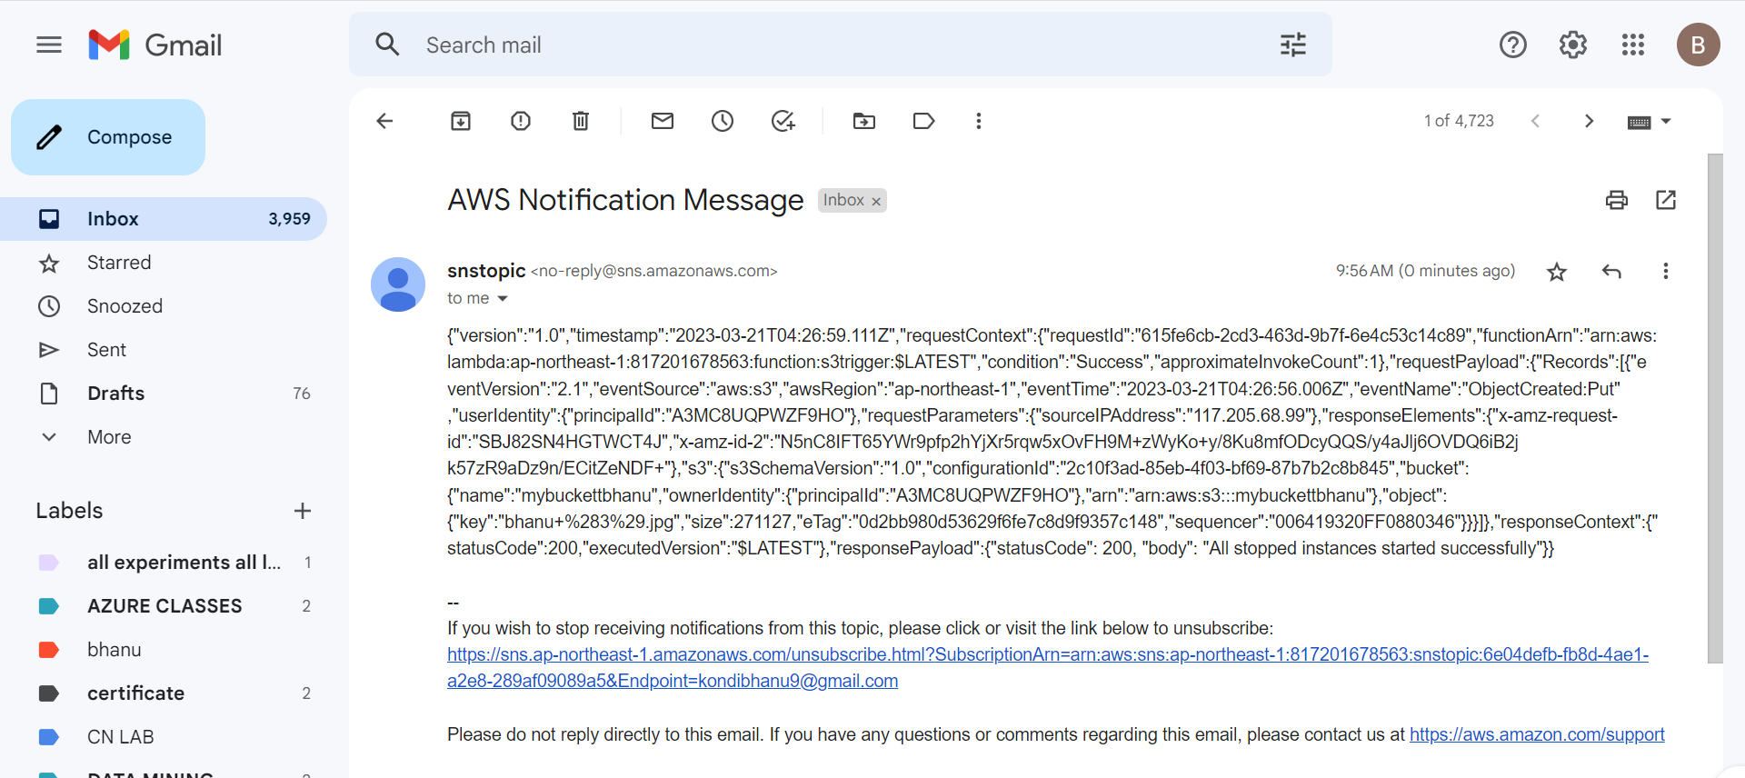

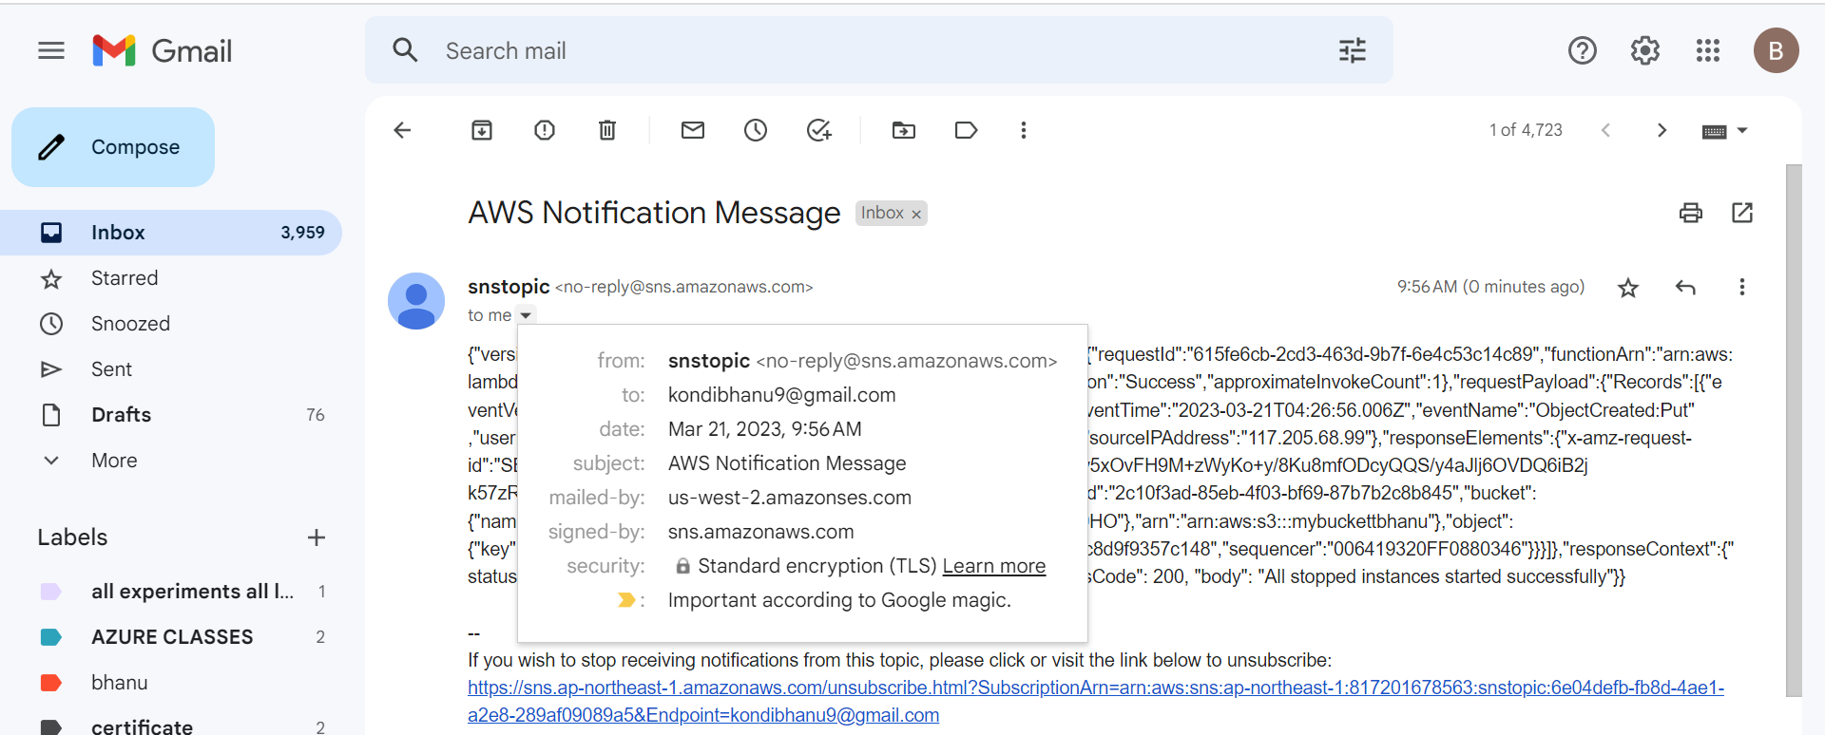

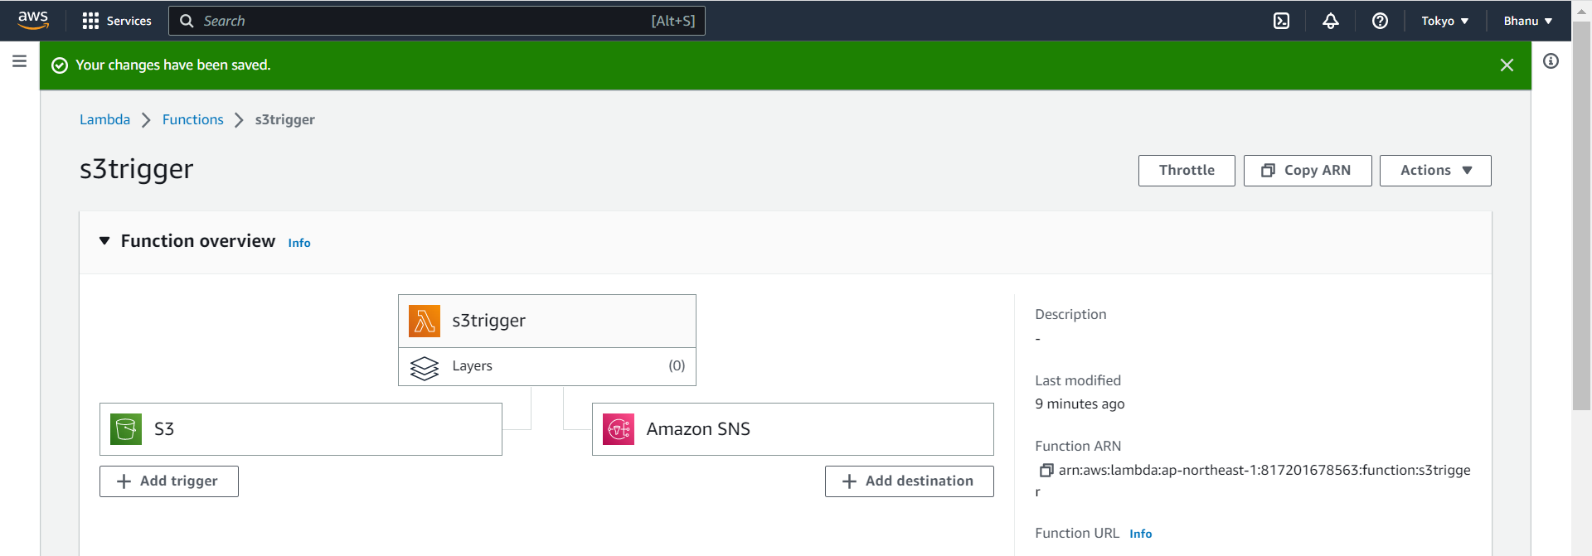

INSTALLING JENKINS:

Next next

Choose run local

8080 port—if it failed then

8000 port and test it

Do next

Program files,go to java then to jdk

Then select install

<https://www.jenkins.io/download/thank-you-downloading-windows-installer-stable/>

<https://www.oracle.com/java/technologies/javase/jdk17-archive-downloads.html>

Bhanu@2004

[Kondibhanu27@gmail.com](mailto:Kondibhanu27@gmail.com)

Bhanu_Kondi

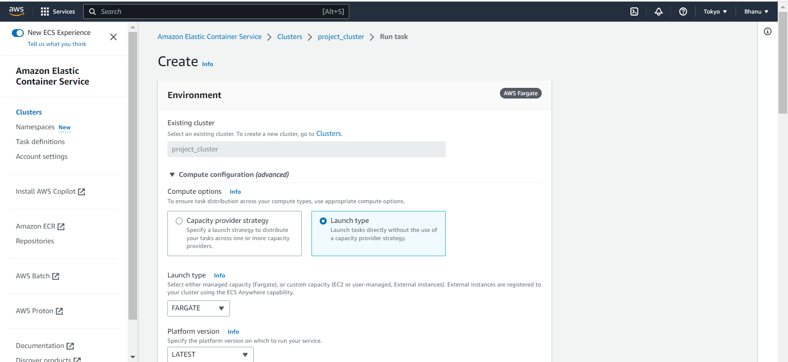

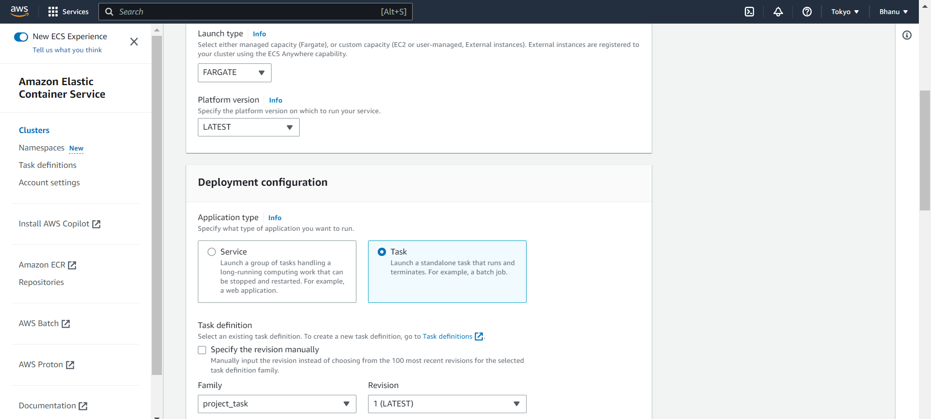

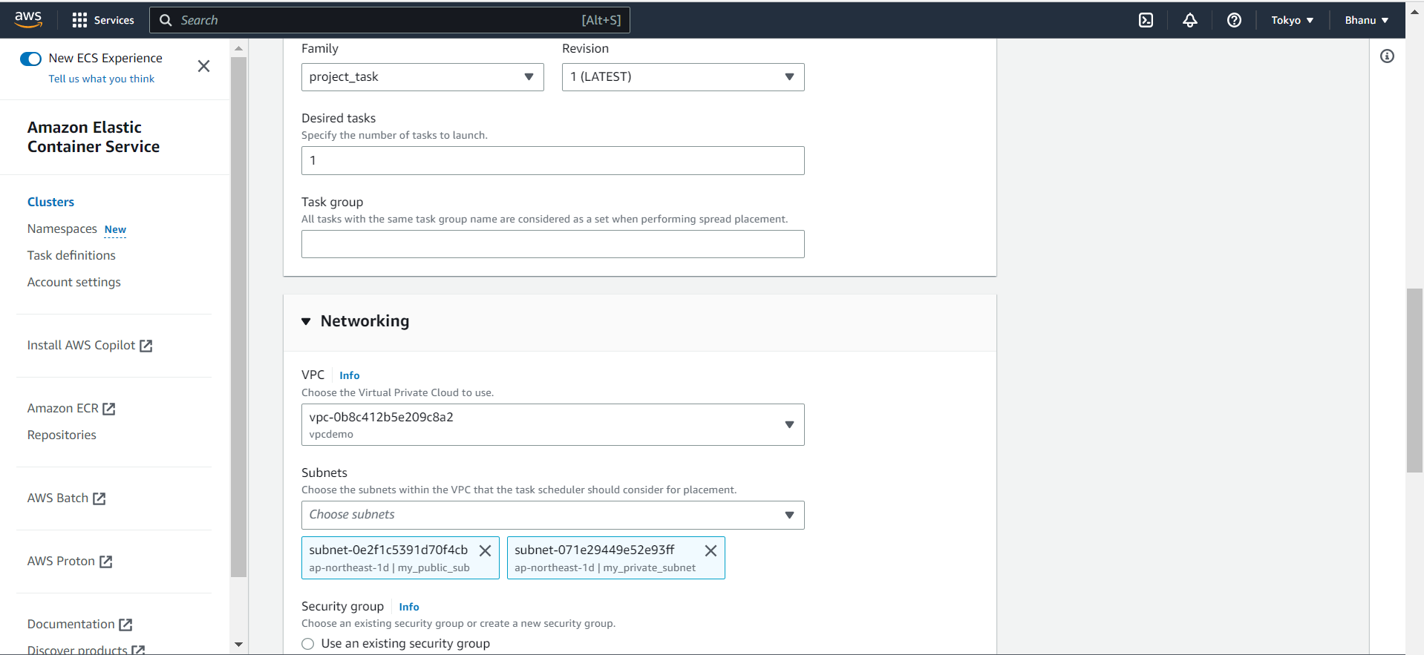

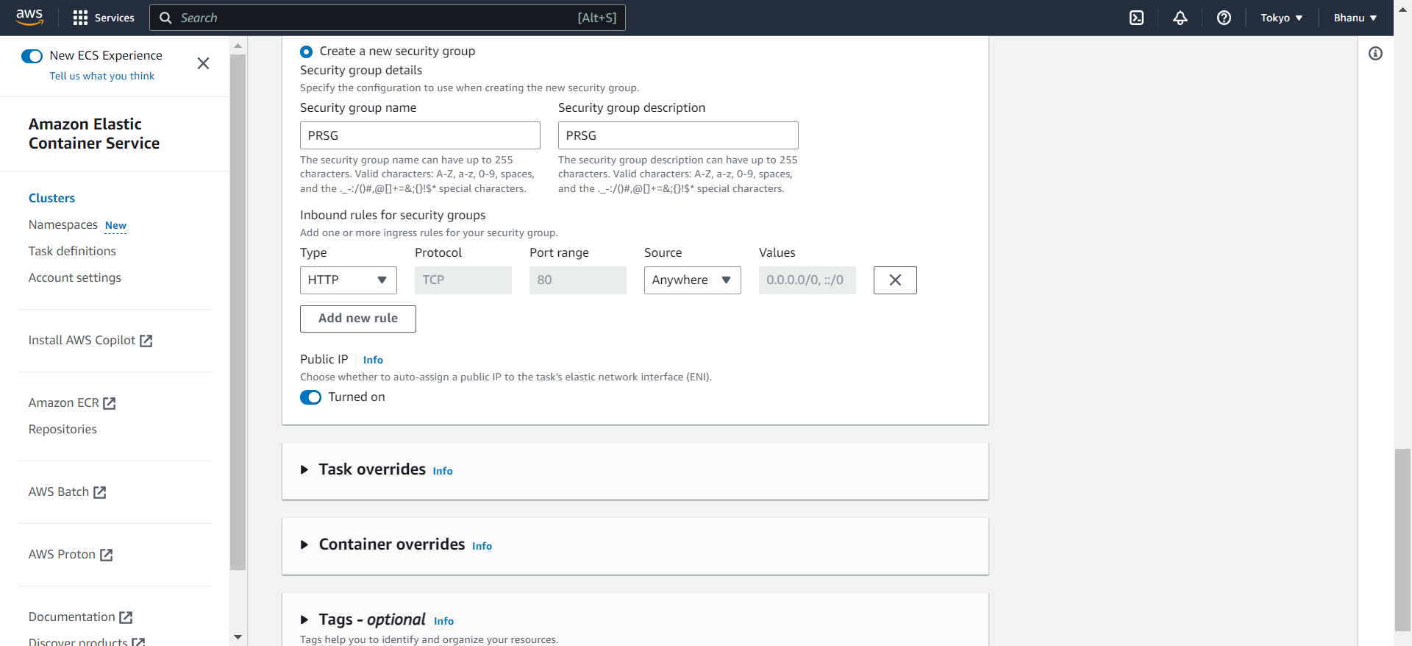

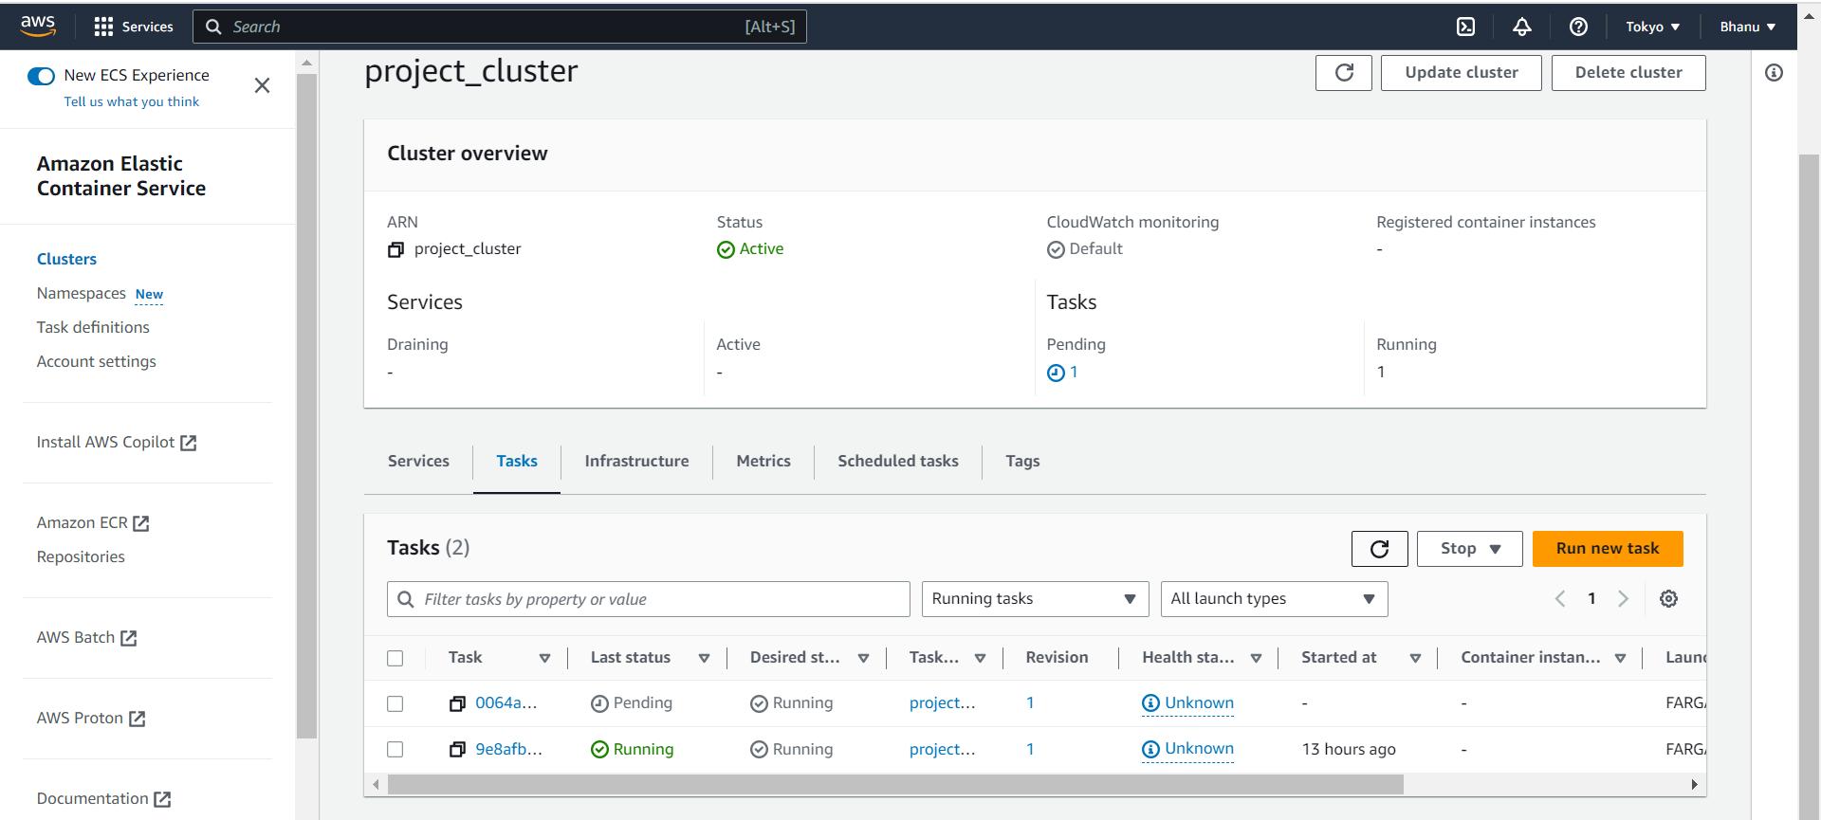

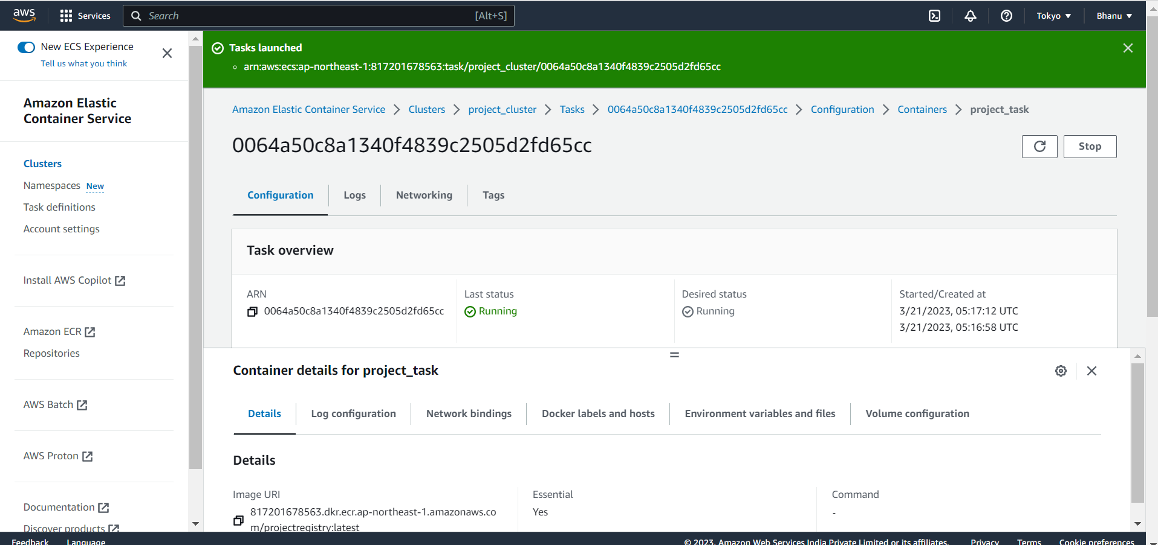

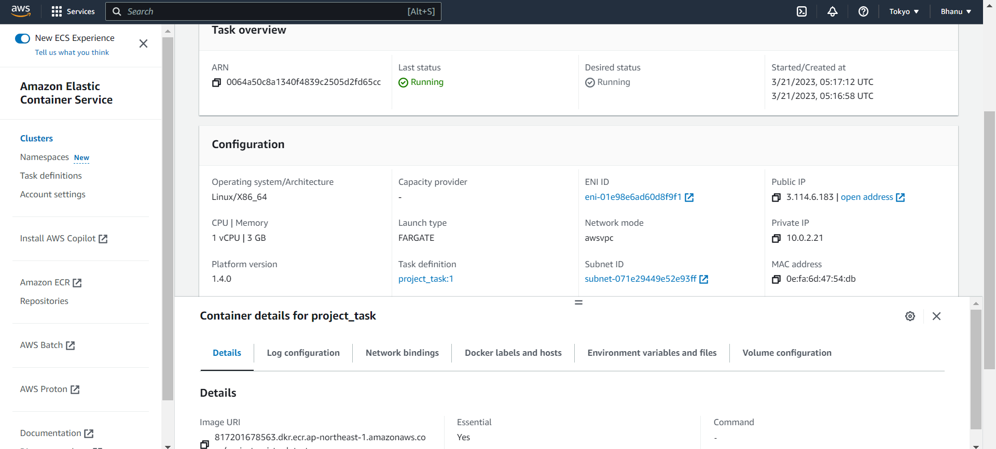

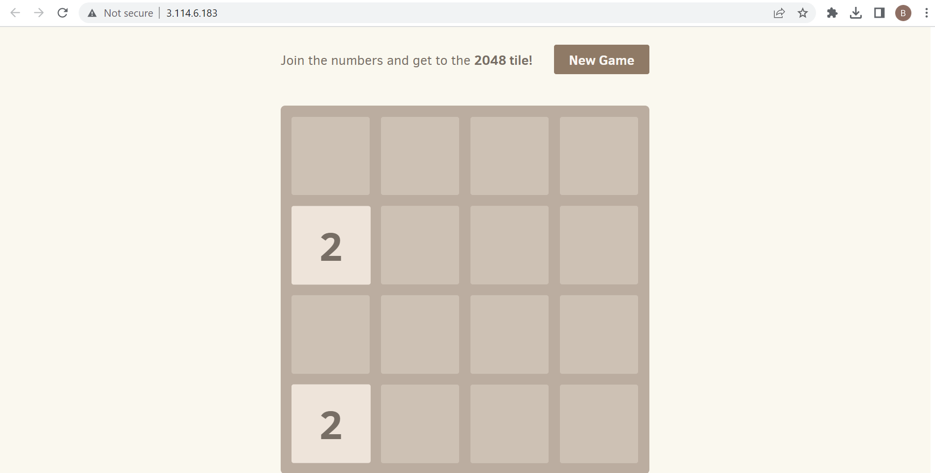

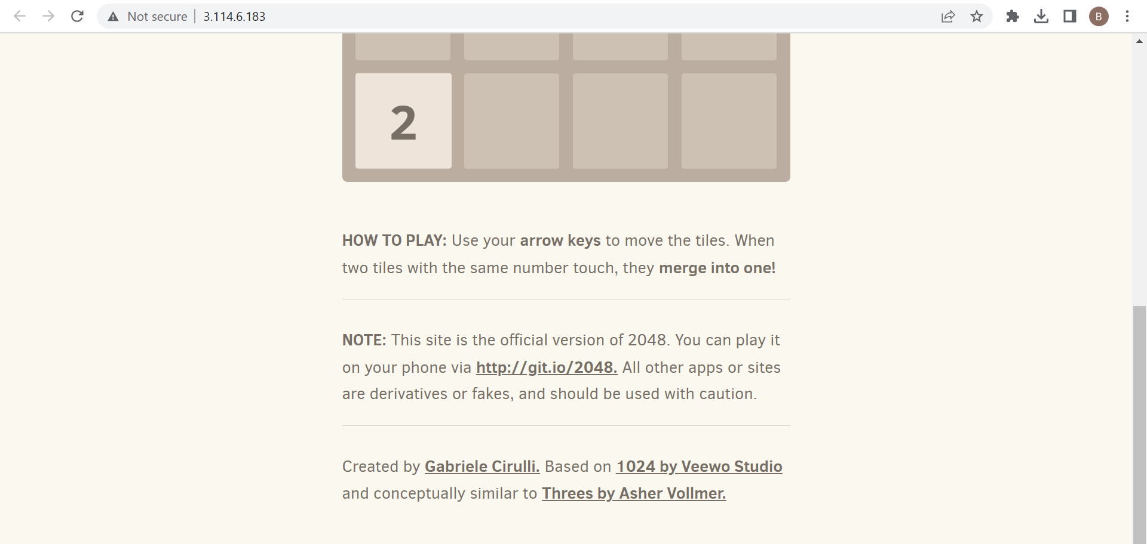

INSTALLING JENKINS:

Next next

Choose run local

8080 port—if it failed then

8000 port and test it

Do next

Program files,go to java then to jdk

Then select install

<https://www.jenkins.io/download/thank-you-downloading-windows-installer-stable/>

<https://www.oracle.com/java/technologies/javase/jdk17-archive-downloads.html>

Jenkins is a tool for continuos integration and continuos deployment.

Go to dashboards>manage plugins>plugin manager

There are lot of plugins available.

Jenkins is more powerful because of plugins.

You can install whatever plugins you want and track the progress in download progress.

